**Exp-1 Landing page for PDEU**

**Aim:** To design a landing page for PDEU using HTML only.

**Theory:** A landing page serves as the entry point for a website or an application, designed to deliver a focused and engaging user experience. For this experiment, the goal is to create a visually appealing and informative landing page for Pandit Deendayal Energy University (PDEU) using only HTML.

Tags used:

1. <!DOCTYPE html> - Defines the document as HTML5.
2. <html> - Root element of the HTML document.
3. <head> - Contains metadata like title and viewport settings.
4. <meta> - Provides metadata (e.g., character set, responsive design).
5. <title> - Sets the page's title in the browser tab.
6. <body> - Contains the visible content of the page.
7. <div> - Groups elements together for layout or styling.
8. <img> - Displays images on the page.
9. <font> - Specifies font size, color, or style (deprecated, avoid using).
10. <a> - Creates hyperlinks for navigation.
11. <section> - Defines thematic sections of content.
12. <hr> - Inserts a horizontal line to separate content.
13. <ul> - Creates an unordered list.
14. <li> - Defines individual list items in a list.
15. <button> - Creates a clickable button.

**Code:**

<!DOCTYPE html>

<html lang="en">

<head>

    <meta charset="UTF-8">

    <meta name="viewport" content="width=device-width, initial-scale=1.0">

    <title>Pandit Deendayal Energy University</title>

</head>

<body link="darkgreen" vlink="darkgreen" alink="darkgreen">

    <div align="center">

        <div>

            <div>

                <img src="logo_full.png" alt="PDEU" width="350" height="100">

                <font size="6" color="blue">

                    <div><b>Enter the World of Top Class Education and Exposure to Modern Technology</b></div>

                </font>

            </div>

            <div>

                <font size="4" color="darkgreen">

                    <a href="#about">About</a> |

                    <a href="#courses">Courses</a> |

                    <a href="#admission">Admission</a> |

                    <a href="#faculty">Faculty</a> |

                    <a href="#campus">Campus</a>

                </font>

            </div>

        </div>

        <hr>

        <section id="about">

            <font size="5" color="orange">

                <div><b>About</b></div>

            </font>

            <font size="4">

                <div align="justify">

                    PDEU was established as a Petroleum University in 2007 with a focus on fossil fuels and later emerged as India's only energy university in the year 2021, dedicated to energy education and research. Today, the university has marked its presence as a renowned institution with noteworthy national and international visibility. PDEU is aggressively contributing towards Nation's AatmaNirbharBharat Abhiyan.

                </div>

            </font>

        </section>

        <hr>

        <section id="courses">

            <font size="5" color="orange">

                <div><b>Courses</b></div>

            </font>

            <font size="4">

                <div align="justify">

                    Pdeu provides 4 main Schools for different fields of education:

                    <ul>

                        <li>School of Management (SoM)</li>

                        <li>School of Liberal Studies (SLS)</li>

                        <li>School of Energy Technology (SoET)</li>

                        <li>School of Technology (SoT)</li>

                    </ul>

                    <div>All of these schools provide top-notch Courses related to their domains, such as:

                        <ul>

                            <li>Computer Science</li>

                            <li>Information and Communication Technology</li>

                            <li>Electronics and Communication</li>

                            <li>Mechanical Engineering</li>

                            <li>Civil Engineering</li>

                            <li>

                                <button>

                                    <a href="https://pdeu.ac.in/academics" target="_blank">Click to check more courses</a>

                                </button>

                            </li>

                        </ul>

                    </div>

                </div>

            </font>

        </section>

        <hr>

        <section id="admission">

            <font size="5" color="orange">

                <div><b>Admission</b></div>

            </font>

            <font size="4">

                <div align="justify">

                    Admission at PDEU involves a comprehensive process where students are evaluated based on their academic performance, entrance test scores, and overall aptitude for specialized fields. The university offers various undergraduate, postgraduate, and doctoral programs in engineering, technology, management, and liberal arts. With a focus on holistic development, PDEU ensures that every student receives quality education and ample opportunities for research and internships.

                </div>

                <button><a href="https://pdpu.ac.in/admissions-bachelor.html">Click to apply for Admission</a></button>

            </font>

        </section>

        <hr>

        <section id="faculty">

            <font size="5" color="orange">

                <div><b>Faculty</b></div>

            </font>

            <font size="4">

                <div align="justify">

                    PDEU boasts a dedicated team of experienced faculty members who are experts in their respective fields. The faculty is committed to delivering high-quality education through innovative teaching methods, research, and industry collaboration. Their guidance helps students excel in academics as well as personal development. With a diverse group of educators, PDEU ensures a rich learning environment that prepares students for real-world challenges.

                </div>

            </font>

        </section>

        <hr>

        <section id="campus">

            <font size="5" color="orange">

                <div><b>Campus</b></div>

            </font>

            <font size="4">

                <div align="justify">

                    The PDEU campus is equipped with state-of-the-art infrastructure and modern facilities to support academic and extracurricular activities. From well-equipped classrooms and laboratories to sports complexes and libraries, the campus offers a conducive environment for learning and growth. The vibrant campus life includes cultural events, seminars, and research programs that promote overall student engagement and development.

                </div>

                <div>

                    <img src="https://pdpu.ac.in/infra/8.jpg" alt="" width="250" height="150">

                    <img src="https://pdpu.ac.in/infra/7.jpg" alt="" width="250" height="150">

                    <img src="https://pdpu.ac.in/infra/2.jpg" alt="" width="250" height="150">

                    <img src="https://sot.pdpu.ac.in/infra/5.jpg" alt="" width="250" height="150">

                    <img src="https://image-static.collegedunia.com/public/college_data/images/campusimage/1585991567010.jpg?mode=stretch" alt="" width="250" height="150">

                </div>

            </font>

        </section>

        <hr>

    </div>

</body>

</html>

**Output:**

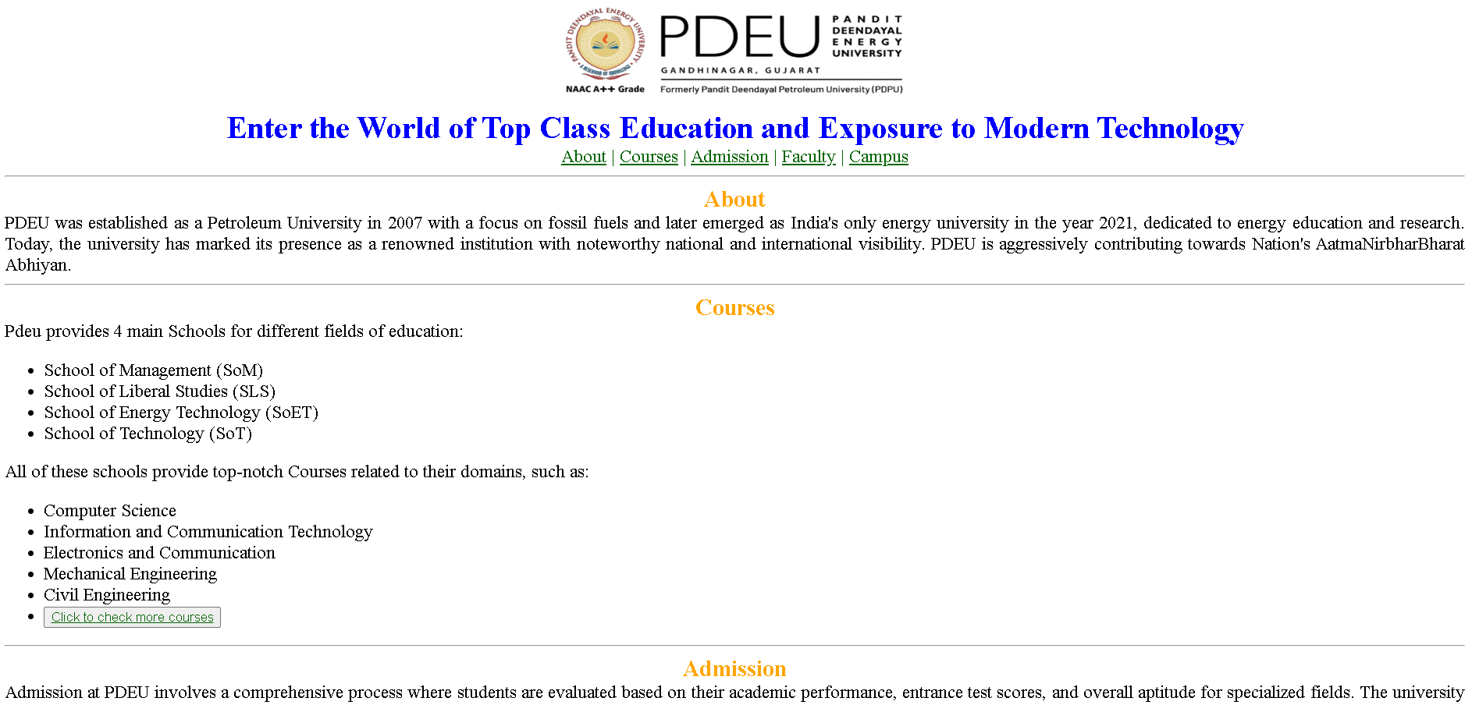

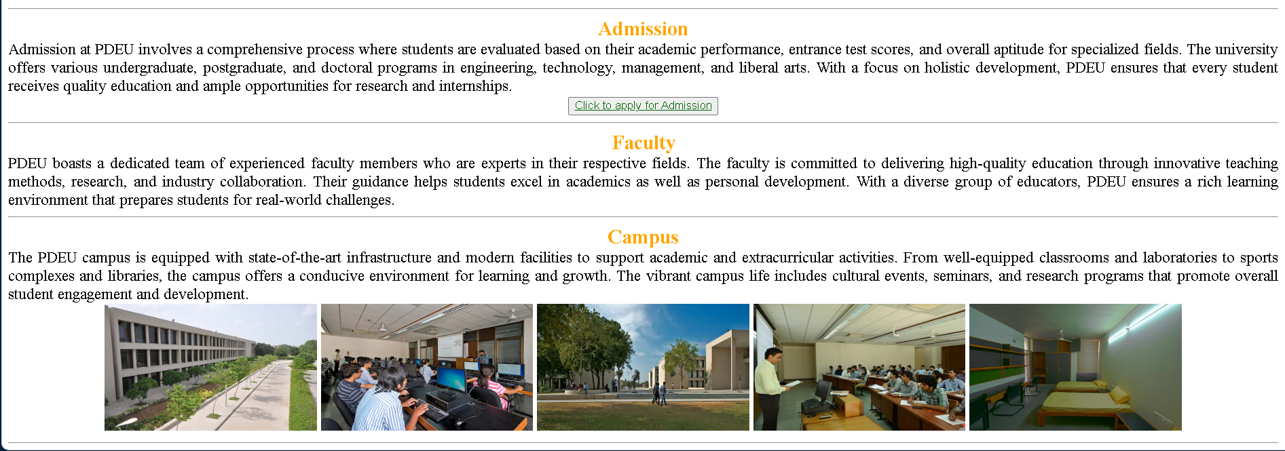

After css:

